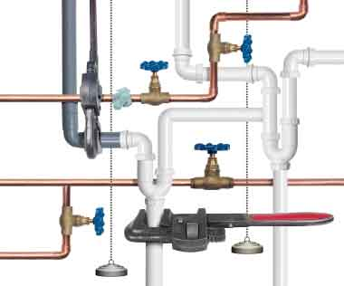  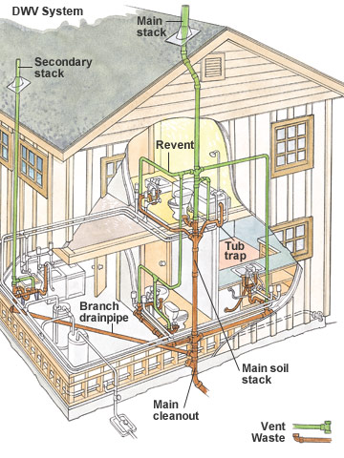  Position available:  PLUMBING teacher  A rewarding teaching position is available to provide instruction for high school students in the theory and practices of Plumbing. Teacher collaborates with the Construction Trades Foundation team of industry partners and other faculty to provide students with hands-on experiences in building and selling of single-family houses as part of the Young America project, demonstrates proficiency in the Plumbing industry and infuses technology into the curriculum.  Duties will include: Planning, conducting, and assessing classroom instructional activities following the NCCER plumbing curriculum to teach the installation, maintenance, and repair of many types of pipe systems. Standards covered include safety; plumbing tools; plumbing math; plumbing drawings; plastic pipe and fittings; copper pipe and fittings; cast-iron pipe and fittings; carbon steel pipe and fittings; corrugated stainless steel tubing; fixtures and faucets; drain, waste, and vent systems; water distribution systems; roof, floor, and area drains; valves; installing water heaters; fuel gas systems; hangers, supports, structural penetrations and fire stopping. The instructor must maintain educational records; inventory and tool control; track achievement of desired program outcomes by coordinating and administering tests and developing and alternative instruction for individualized and independent study. | Apply Today by  Contacting Staffing:  Tiffanyann_L_ Johnson  @mcpsmd.org  Or  Principal Shawn Krasa  240-740-2000  For Curriculum and Teaching Questions:  240-740-2050  Steven_D_Boden@mcpsmd.org  ────  Join Our Team of Career Educators!  Montgomery County Students Construction Trades Foundation, Inc.  12501 Dalewood Drive,  Silver Spring, MD 20906

