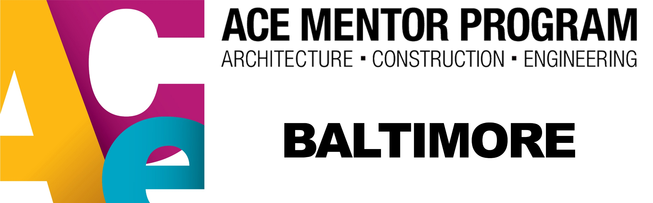
Media Contact:
Kimberly Hahr
ACE Mentor of Baltimore
410-704-5956
khahr@acebaltimore.org

FOR IMMEDIATE RELEASE:

ACE Mentor Program of Baltimore Hosts the ACE Industry Fair for Students
Students throughout Baltimore City, Baltimore County, and Howard County will have the opportunity to explore local architecture, construction and engineering companies.

BALTIMORE, MD (January 16, 2020) – ACE Mentor Program of Baltimore’s Industry Fair for Students will take place on January 16th from 2:00 to 5:00 p.m. at the Mansion House at the Maryland Zoo. At this event, 25 vendors will be available to both high school and college students. Students will discuss the next steps in pursuing a built environment career including job opportunities, internships, training, degrees, and more.

ACE (an acronym for architecture, construction, and engineering) is a mentor program that is in high schools across America. Industry professionals from the built environment industry meet with a specific high school team over the span of 15 weeks to help the students gain knowledge and experience in all aspects of the industry.

Throughout the year teams from schools across Baltimore City, Baltimore County, and Howard County will create worksite plans for the University of Maryland Marlene and Stewart Greenbaum Comprehensive Cancer Center. At Presentation Night these teams will go in front of a panel of judges to pitch how they would develop the existing site. At the end of the night, the judges will decide on which team had the best worksite plan and pitch and award a winner.

For vendors, the Industry Fair is an opportunity to get in front of students and inform them about the next steps to take in their pursuit of a built environment career. With the booming industry in Maryland, this event promotes the built environment industry as a whole as well as the companies and educational organizations.

Students will not only have the chance to explore career opportunities, but also have the chance to explore Maryland college programs and learn more about internship opportunities with the Maryland Department of Housing & Community Development (DHCD.)

For more information on ACE Baltimore, or sign up for the ACE Baltimore Industry Fair for Students, please contact Kimberly Hahr at khahr@acementor.org or by phone at 410-704-5956.
###

